

**PF - Project**

**Batch (CS-13 )**

**Group Members**

**M. Ramzan Arif (CS-06)**

**M. Umer Yousaf (CS-07)**

**Adnan Hashim (CS-08)**

**Submitted To:** Mamm Saba Ramzan

**Project Code**

#include<iostream>

#include<fstream>

#include<string>

using namespace std;

int multiple(int a,int b);

int Store_price (int price ,int sum);

int main()

{

int userchoice;

int switch_loop , quantity , price=0 , Q_price=1 ,Total_sum=0;

cout<<endl;

cout<<endl;

cout<<"!!!!!!!!!!!!!!!!!!!!!!!!!!!!!!!!!!!!!!!!!!!!!!!!!!!!!!!!!!!!!!!!!!!!!!!!!!!!!!!!!!!!!!!!!!!!!!!!!!!!!!!!!!!!!!!!!!!!!!!!!!!!!!!!!!!!!!!!!!"<<endl;

cout<<endl;

cout<<"!! !!!! !! ! ! !!! !! ! !!!!!! !!!!! ! ! !!!! !!!! !!!! !!! !! ! !!!!! !! !! ! !!!! ! ! !!!!! !!!!!!! !!"<<endl;

cout<<"!! ! ! ! ! ! ! ! ! ! ! !!! !! !!!!! ! ! ! ! ! ! ! ! ! ! ! ! ! ! ! ! ! ! ! !!! !!! ! !!"<<endl;

cout<<"!! ! ! ! ! ! ! ! ! ! ! !!! !! !!!!! ! ! !!!! !!!! ! ! ! ! ! !!! ! ! ! ! !!!!! !!!! !! !!! ! !!"<<endl;

cout<<"!! !!!! ! !! !!!!! !!! ! !! !!!!!! !!!!! ! ! !!!! ! ! !!! ! !! !!!!! ! ! ! ! ! ! ! ! ! !!!!! ! !!"<<endl;

cout<<endl;

cout<<"!!!!!!!!!!!!!!!!!!!!!!!!!!!!!!!!!!!!!!!!!!!!!!!!!!!!!!!!!!!!!!!!!!!!!!!!!!!!!!!!!!!!!!!!!!!!!!!!!!!!!!!!!!!!!!!!!!!!!!!!!!!!!!!!!!!!!!!!!!"<<endl;

cout<<endl;

cout<<"\n";

cout<<"LOGIN----REGISTRATION----SYSTEM"<<endl;

cout<<"\n";

// open the file for reading and writing

fstream file("users.txt", ios::in | ios::out | ios::app);

// check if the file was opened successfully

if (!file.is_open())

{

cout << "Error opening file." << endl;

return 1;

}

// ask the user if they want to login or register

cout << "Do you want to login or register? "<<endl;

cout<<"1) Login press (l)"<<endl;

cout<<"2) Register press (r)"<<endl;

char choice;

cin >> choice;

// handle login

if (choice == 'l')

{

string username, password;

bool found = false;

// get user input for username and password

cout << "Enter username: ";

cin >> username;

cout << "Enter password: ";

cin >> password;

// search the file for the given username and password

string line;

while (getline(file, line))

{

if (line.find(username + " " + password) != string::npos)

{

found = true;

break;

}

}

// handle login success or failure

if (found)

{

cout << "Login successful." << endl;

cout<<endl;

cout<<"Do you want to buy something"<<endl;

cout<<endl;

cout<<"If you buy anything type 1 if you don't want to buy anything so press any key to continue"<<endl;

cout<<endl;

cin>>userchoice;

cout<<"------------------------------------------------------------------------------------------------------------------------"<<endl;

if(userchoice==0){

cout<<"Thankyou for Coming our market";

}

if(userchoice==1)

{

do{

cout<<endl;

cout<<"\t\t\t\t\tOur Menue: "<<endl;

cout<<endl;

cout<<"\t\t\t\t\tSelect any one: "<<endl;

cout<<"\t\t\t\t\t1. Food"<<endl;

cout<<"\t\t\t\t\t2. Communication Devices"<<endl;

cout<<"Choose (1-2): ";

cin>>userchoice;

if(userchoice==1)

{

cout<<"\t\t\t\t\tMenue of Foods"<<endl;

cout<<"\t\t\t\t\tChoose which you want: "<<endl;

cout<<endl;

cout<<"\t\t\t\t\t1.Burgers"<<endl;

cout<<"\t\t\t\t\t2.Pizza"<<endl;

cout<<"\t\t\t\t\t3.Shawarama"<<endl;

cout<<"\t\t\t\t\t4.Deals"<<endl;

cout<<"\t\t\t\t\t5.No I don't need"<<endl;

cin>>userchoice;

if(userchoice==1)

{

do{

// Declare Variables

{

cout<<"\t\t\t\t\t1. Shami Burger RS. 110/-"<<endl;

cout<<"\t\t\t\t\t2. Beff Burger RS. 450/-"<<endl;

cout<<"\t\t\t\t\t3. Zinger Burger RS. 300/-"<<endl;

cout<<"\t\t\t\t\t4. Cheese Burger RS. 400/-"<<endl;

cout<<"\t\t\t\t\t5. Tower Buger RS. 550/-\n"<<endl; }

cout<<"Choose option 1 to 5 : ";

cin>>userchoice;

cout<<endl;

cout<<"Enter quantity of product: ";

cin>>quantity;

switch(userchoice)

{

case 1:{

price=110;

break;}

case 2:{

price=450;

break;}

case 3:{

price=300;

break;}

case 4:{

price=400;

break;}

case 5:{

price=550;

break;}

default:{

cout<<"Invalid! Type"<<endl;}

}

Q_price = multiple( price , quantity ); // Quantity function

Store_price( Q_price , Total_sum); // Store price

Total_sum=Store_price(Q_price, Total_sum);

cout<<"\nDo you Want to Buy again ? Press (1).";

cin>>switch_loop;

cout<<endl;

}while(switch_loop==1);

cout<<"Your Total Price is: "<<"Rs"<<Total_sum<<endl;

cout<<"**************************************************************************************************************************************"<<endl;

}

if(userchoice==2)

{

do{

cout<<"\t\t\t\t\tMenue of Pizzas"<<endl;

cout<<"\t\t\t\t\t1. Chicken Fajjita (small) RS. 450/-"<<endl;

cout<<"\t\t\t\t\t2. Chicken Fajjita (meduim) RS. 850/-"<<endl;

cout<<"\t\t\t\t\t3. Chicken Fajjita (Large) RS. 1150/-"<<endl;

cout<<endl;

cout<<"\t\t\t\t\t4. Chicken Tikka (small) RS. 450/-"<<endl;

cout<<"\t\t\t\t\t5. Chicken Tikka (meduim) RS. 850/-"<<endl;

cout<<"\t\t\t\t\t6. Chicken Tikka (Large) RS. 1150/-"<<endl;

cout<<endl;

cout<<"\t\t\t\t\t7. Chicken Supreme (small) RS. 450/-"<<endl;

cout<<"\t\t\t\t\t8. Chicken Supreme (meduim) RS. 850/-"<<endl;

cout<<"\t\t\t\t\t9. Chicken Supreme (Large) RS. 1150/-"<<endl;

cout<<endl;

cout<<"\t\t\t\t\t10. Chicken Crown Crust pizza (small) RS. 550/-"<<endl;

cout<<"\t\t\t\t\t11. Chicken Crown Crust pizza (meduim) RS. 950/-"<<endl;

cout<<"\t\t\t\t\t12. Chicken Crown Crust pizza (Large) RS. 1300/-"<<endl;

cout<<endl;

cout<<"Choose option 1 to 12 : ";

cin>>userchoice;

cout<<endl;

cout<<"Enter quantity of product : ";

cin>>quantity;

switch(userchoice)

{

case 1 :{

price=450;

break;}

case 2:{

price=850;

break;}

case 3:{

price=1150;

break;}

case 4:{

price=450;

break;}

case 5:{

price=850;

break;}

case 6:

price=1150;

break;

case 7:

price=450;

break;

case 8:

price=850;

case 9:

price=1150;

case 10:

price=550;

case 11:

price=950;

case 12:

price=1300;

default:{

cout<<"Invalid! Type"<<endl;}

}

Q_price = multiple( price , quantity);

Store_price( Q_price , Total_sum);

Total_sum=Store_price(Q_price, Total_sum);

cout<<"\nDo you Want to Buy again ? Press (1).";

cin>>switch_loop;

cout<<endl;

}while(switch_loop==1);

cout<<"Your Total Price is: "<<"Rs"<<Total_sum<<endl;

cout<<"******************************************************************************************************************************************"<<endl;

}

if(userchoice==3)

{

do{

{

cout<<"\t1. Chicken Shawarma RS. 150/-"<<endl;

cout<<"\t2. Zinger Shawarma RS. 300/-"<<endl;

cout<<"\t3. Chicken Grilled Paratha Roll RS. 400/-"<<endl;

cout<<"\t4. Beef Shawarma RS. 500/-"<<endl;

cout<<"\t5. Chicken Beef Shawarma RS. 550/-\n"<<endl; }

cout<<"Choose option 1 to 5 : ";

cin>>userchoice;

cout<<"Enter quantity of product : ";

cin>>quantity;

switch(userchoice)

{

case 1:{

price=150;

break;}

case 2:{

price=300;

break;}

case 3:{

price=400;

break;}

case 4:{

price=500;

break;}

case 5:{

price=550;

break;}

default:{

cout<<"Invalid! Type"<<endl;}

}

Q_price = multiple( price , quantity ); // Quantity function

Store_price( Q_price , Total_sum); // Store price

Total_sum=Store_price(Q_price, Total_sum);

cout<<"\nDo you Want to Buy again ? Press (1).";

cin>>switch_loop;

cout<<endl;

}while(switch_loop==1);

cout<<"Your Total Price is: "<<"Rs"<<Total_sum<<endl;

}

if(userchoice==4){

cout<<"\t1. Family Deal "<<endl;

cout<<"\t2. Pizza Deals "<<endl;

cout<<"\t3. Special Combo "<<endl;

cout<<endl;

cout<<"Choose (1-3)"<<endl;

cin>>userchoice;

if(userchoice==1){

do{

cout<<"\t1. 3 Medium Pizza , 3 Zinger Burger, 4 Chicken Shawarma, 2 Tower Burger ,2.5 Liter Drink (2800 Rs)"<<endl;

cout<<"\t2. 4 Large Pizza , 1 Cheese Burger, 3 Tower Burger ,6 Zinger Shawarma ,1.5 Liter Drink (3500 Rs)"<<endl;

cout<<"\t3. 6 Shami Burger ,2 Small Pizza ,6 Chicken Shawarama, 1.5 Liter Drink (1800 Rs)"<<endl;

cout<<"Choose option 1 to 3 : ";

cin>>userchoice;

cout<<"Enter quantity of product : ";

cin>>quantity;

switch(userchoice)

{

case 1:{

price=2800;

break;}

case 2:{

price=3500;

break;}

case 3:{

price=1800;

break;}

default:{

cout<<"Invalid! Type"<<endl;}

}

Q_price = multiple( price , quantity );

Store_price( Q_price , Total_sum);

Total_sum=Store_price(Q_price, Total_sum);

cout<<"\nDo you Want to Buy again ? Press (1).";

cin>>switch_loop;

cout<<endl;

}while(switch_loop==1);

cout<<"Your Total Price is: "<<"Rs"<<Total_sum<<endl;

}

if(userchoice==2){

do{

{

cout<<"1. 3 Small Pizza, 1 Large Pizza (1500 Rs)"<<endl;

cout<<"2. 2 Large Pizza, 3 Medium Pizza (2500 Rs)"<<endl;

cout<<"3. 3 Large Pizza, 2 Medium Pizza, 1 Small Pizza, 2.5 Liter Drink (3500 Rs)"<<endl;

}

cout<<"Choose option 1 to 3 : ";

cin>>userchoice;

cout<<"Enter quantity of product : ";

cin>>quantity;

switch(userchoice)

{

case 1:{

price=1500;

break;}

case 2:{

price=2500;

break;}

case 3:{

price=3500;

break;}

default:{

cout<<"Invalid! Type"<<endl;}

}

Q_price = multiple( price , quantity );

Store_price( Q_price , Total_sum);

Total_sum=Store_price(Q_price, Total_sum);

cout<<"\nDo you Want to Buy again ? Press (1).";

cin>>switch_loop;

cout<<endl;

}while(switch_loop==1);

cout<<"Your Total Price is: "<<"Rs"<<Total_sum<<endl;

}

if(userchoice==3){

do{

{

cout<<"1. 1 Zinger Burger , 1/2 Liter Drink (350 Rs)"<<endl;

cout<<"2. 3 Chicken Shawarama ,1/2 Liter Drink (400 Rs)"<<endl;

cout<<"3. 3 Shami Burger , 1 Tower Burger ,1 Liter Drink (550 Rs)"<<endl;

}

cout<<"Choose option 1 to 3 : ";

cin>>userchoice;

cout<<"Enter quantity of product : ";

cin>>quantity;

switch(userchoice)

{

case 1:{

price=350;

break;}

case 2:{

price=400;

break;}

case 3:{

price=550;

break;}

default:{

cout<<"Invalid! Type"<<endl;}

}

Q_price = multiple( price , quantity );

Store_price( Q_price , Total_sum);

Total_sum=Store_price(Q_price, Total_sum);

cout<<"\nDo you Want to Buy again ? Press (1).";

cin>>switch_loop;

cout<<endl;

}while(switch_loop==1);

cout<<"Your Total Price is: "<<"Rs"<<Total_sum<<endl;

}

}

if(userchoice==5){

cout<<"Thankyou for Coming our Online Shopping Market"<<endl;

}

cout<<endl;

}

if(userchoice==2){

cout<<endl;

cout<<"\t1. Mobiles"<<endl;

cout<<"\t2. Smart Watches"<<endl;

cin>>userchoice;

cout<<endl;

if(userchoice==1){

cout<<"We have three Varities of Mobile Companies: "<<endl;

cout<<endl;

cout<<"\t1. Samsung"<<endl;

cout<<"\t2. Vivo"<<endl;

cout<<"\t3. Oppo"<<endl;

cout<<"Choose Brand (1-3)"<<endl;

cin>>userchoice;

cout<<endl;

if(userchoice==1){

do{

{

cout<<"We have 5 Models of Samsung Mobile"<<endl;

cout<<endl;

cout<<"\t1. Samsung Galaxy A14 5G (54,999 Rs)"<<endl;

cout<<"\t2. Samsung Galaxy A34 (79,999 Rs)"<<endl;

cout<<"\t3. Samsung Galaxy A13s (38,999 Rs)"<<endl;

cout<<"\t4. Samsung Galaxy A54 (115,999 Rs)"<<endl;

cout<<"\t5. Smasung Galaxy F13 (34,999 Rs)"<<endl;

}

cout<<"Choose option 1 to 5 : ";

cin>>userchoice;

cout<<"Enter quantity of product : ";

cin>>quantity;

switch(userchoice)

{

case 1:{

price=54999;

break;}

case 2:{

price=79999;

break;}

case 3:{

price=38999;

break;}

case 4:{

price=115999;

break;}

case 5:{

price=34999;

break;

}

default:{

cout<<"Invalid! Type"<<endl;}

}

Q_price = multiple( price , quantity );

Store_price( Q_price , Total_sum);

Total_sum=Store_price(Q_price, Total_sum);

cout<<"\nDo you Want to Buy again ? Press (1).";

cin>>switch_loop;

cout<<endl;

}while(switch_loop==1);

cout<<"Your Total Price is: "<<"Rs"<<Total_sum<<endl;

}

if(userchoice==2){

do{

{

cout<<"We have 5 Models of Vivo Mobile"<<endl;

cout<<endl;

cout<<"\t1. V25 5G. (Rs. 109,999)"<<endl;

cout<<"\t2. V25e. (Rs. 109,999)"<<endl;

cout<<"\t3. Y16. (Rs. 67,999)"<<endl;

cout<<"\t4. Y22. (Rs. 69,999)"<<endl;

cout<<"\t5. Y02s. (Rs. 49,999)"<<endl;

}

cout<<"Choose option 1 to 5 : ";

cin>>userchoice;

cout<<"Enter quantity of product : ";

cin>>quantity;

switch(userchoice)

{

case 1:{

price=109999;

break;}

case 2:{

price=109999;

break;}

case 3:{

price=67999;

break;}

case 4:{

price=69999;

break;}

case 5:{

price=49999;

break;

}

default:{

cout<<"Invalid! Type"<<endl;}

}

Q_price = multiple( price , quantity ); // Quantity function

Store_price( Q_price , Total_sum); // Store price

Total_sum=Store_price(Q_price, Total_sum);

cout<<"\nDo you Want to Buy again ? Press (1).";

//cout<<"Press 0 Otherwise press any key to Continue. . . ."<

cin>>switch_loop;

cout<<endl;

}while(switch_loop==1);

cout<<"Your Total Price is: "<<"Rs"<<Total_sum<<endl;

}

if(userchoice==3){

do{

{

cout<<"We have 4 Models of Vivo Mobile"<<endl;

cout<<endl;

cout<<"\t1. Oppo F21 Pro 5G (Rs. 104999)"<<endl;

cout<<"\t2. Oppo F21 Pro (Rs. 89999)"<<endl;

cout<<"\t3. Oppo A96 (Rs. 77999)"<<endl;

cout<<"\t4. Oppo A16e (Rs. 59999)"<<endl;

}

cout<<"Choose option 1 to 4 : ";

cin>>userchoice;

cout<<"Enter quantity of product : ";

cin>>quantity;

switch(userchoice)

{

case 1:{

price=104999;

break;}

case 2:{

price=89999;

break;}

case 3:{

price=77999;

break;}

case 4:{

price=59999;

break;}

default:{

cout<<"Invalid! Type"<<endl;}

}

Q_price = multiple( price , quantity );

Store_price( Q_price , Total_sum);

Total_sum=Store_price(Q_price, Total_sum);

cout<<"\nDo you Want to Buy again ? Press (1).";

cin>>switch_loop;

cout<<endl;

}while(switch_loop==1);

cout<<"Your Total Price is: "<<"Rs"<<Total_sum<<endl;

}

}

if(userchoice==2){

do{

{

cout<<"We have 4 Models of Smart Mobile"<<endl;

cout<<endl;

cout<<"\t1. Haino Teko H99 Smart Watch Rs. 8,999/-"<<endl;

cout<<"\t2. Kospet Magic 4 Smartwatch Rs. 8,499/-"<<endl;

cout<<"\t3. OPPO Band Style Rs. 10,799/-"<<endl;

cout<<"\t4. ITel ISW 31 Smart Watch Rs. 12,499"<<endl;

}

cout<<"Choose option 1 to 4 : ";

cin>>userchoice;

cout<<"Enter quantity of product : ";

cin>>quantity;

switch(userchoice)

{

case 1:{

price=8999;

break;}

case 2:{

price=8499;

break;}

case 3:{

price=10799;

break;}

case 4:{

price=12499;

break;}

default:{

cout<<"Invalid! Type"<<endl;}

}

Q_price = multiple( price , quantity );

Store_price( Q_price , Total_sum);

Total_sum=Store_price(Q_price, Total_sum);

cout<<"\nDo you Want to Buy again ? Press (1).";

cin>>switch_loop;

cout<<endl;

}while(switch_loop==1);

cout<<"Your Total Price is: "<<"Rs"<<Total_sum<<endl;

}

}

cout<<endl;

cout<<"Do you Want to show our Whole Menue"<<endl;

cin>>userchoice;

}while(userchoice==1);

system("pause");

}

}

else

{

cout << "Invalid username or password." << endl;

}

}

// handle registration

else if (choice == 'r')

{

string username, password;

// get user input for username and password

cout << "Enter username: ";

cin >> username;

cout << "Enter password: ";

cin >> password;

// save the username and password to the file

file << username << " " << password << endl;

cout << "Registration successful." << endl;

}

// handle invalid choice

else

{

cout << "Invalid choice." << endl;

}

// close the file

file.close();

}

int multiple(int a,int b){

return a*b;}

int Store_price (int price ,int sum){

return sum+price;

}

**Console Pages Screenshot**

**Registration System:**

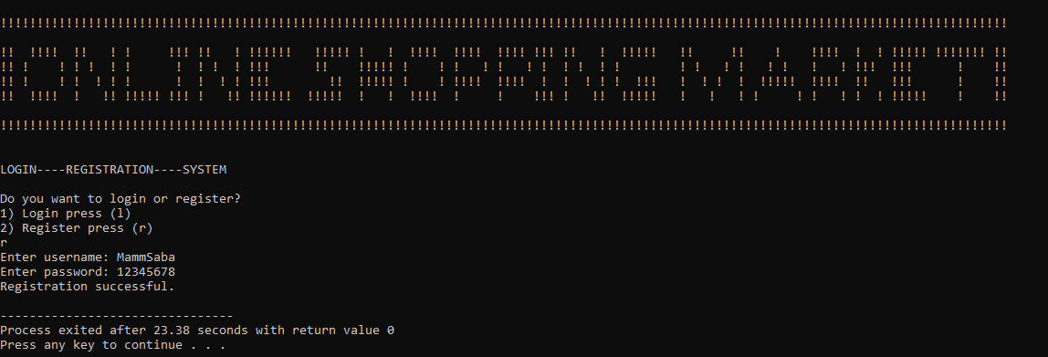

**Login System:**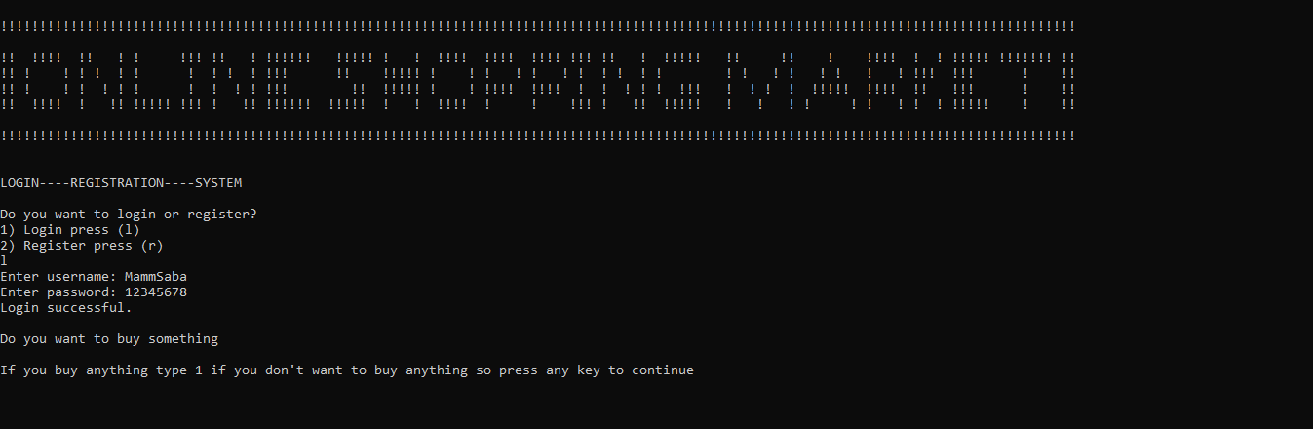

**Menu System:**

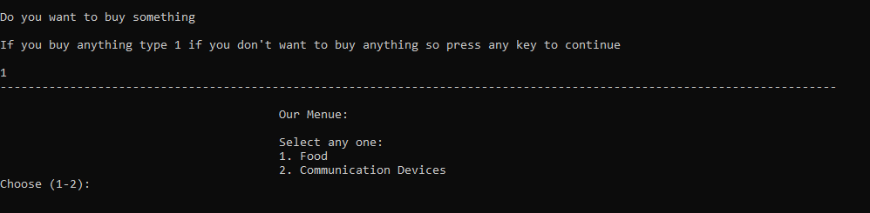

**Food System:**

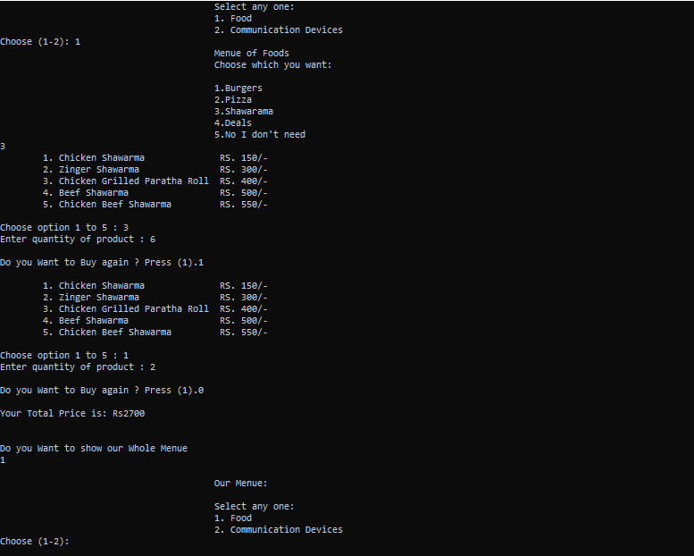

**Communication Devices System:**

